SOFTWARE TESTING
DAY 1 : Introduction to Software Testing
- What is Software Testing?
- Software Testing is the process of checking and evaluating a software application to ensure that it works according to the specified requirements and is free from defects.
- In simple words, software testing means verifying whether an application is working correctly and providing a good experience to the users.
Testing helps us answer questions such as:
- Is the application working as expected?
- Are all the features functioning correctly?
- Does the application handle incorrect inputs properly?
- Can users use the application without facing issues?

- Why is Software Testing Important?
- Improves Software Quality
Testing helps identify defects and ensures that the application works correctly.
Example: Detecting a broken Login button before releasing the application.
- Reduces Production Issues
Finding and fixing defects during development is easier and less expensive than fixing them after release.
Example: Identifying payment failures before customers start using the application.
- Ensures Business Requirements are Met
Testing verifies that the application behaves according to customer requirements.
Example: Verifying that only registered users can log into the application.
- Enhances User Experience
A properly tested application provides a smooth and reliable experience.
Example: Ensuring that error messages are displayed clearly when users enter incorrect passwords.
- Increases Customer Satisfaction
A stable and reliable application builds trust and improves customer satisfaction.
Example: An application that rarely crashes creates a positive experience for users.

- Objectives of Software Testing

1. To Identify Defects
The primary objective of testing is to find bugs and defects before the application reaches end users.

2. To Verify Requirements
Ensure that all features have been implemented according to the requirements.

3. To Validate Application Behavior
Check whether the application behaves as expected under different conditions.

4. To Improve Software Quality
Deliver a reliable, secure, and high-quality product.

5. To Reduce Risks
Prevent major production issues and business losses.

6. To Increase Customer Satisfaction
Provide an application that is easy to use and performs consistently.

- Real-Time Example: Login Page Verification
Consider an application that has a Login page where users enter their username and password to access their account.
As a Test Engineer, I would perform the following checks:
Check 1
Open the Login page and verify that:
- Username field is visible
- Password field is visible
- Login button is visible

Check 2
Enter the correct username and password and verify that:
- User logs in successfully
- Home page is displayed
Check 3
Enter an incorrect password and verify that:
- Appropriate error message is displayed
- User remains on the Login page
Check 4
Leave both fields empty and verify that:
- Validation messages are displayed
Check 5
Enter only the username and verify that:
- Password required message is displayed
Check 6
Click the Login button multiple times and verify that:
- Application responds properly
- No unexpected behavior occurs
This simple example helps us understand how testing ensures that an application works correctly and provides a good user experience.

- Key Learnings
- Software testing is the process of checking whether an application works according to requirements.
- Verification means checking whether we are building the product correctly.
- Validation means checking whether we are building the right product.
- Testing improves software quality and reliability.
- Early bug detection saves time, cost, and effort.
- Testing improves user experience and customer satisfaction.
- Software testing plays an important role in delivering high-quality applications.

DAY 2 : Introduction to SDLC & SDLC Models

- What is SDLC?
Software Development Life Cycle (SDLC) is a structured process followed to develop high-quality software systematically. It defines the phases involved in planning, designing, developing, testing, deploying, and maintaining a software application.
In simple words, SDLC is a step-by-step process that guides the development team from the idea of the software to its maintenance after release.

- Why is SDLC important ?
- Provides a systematic approach to software development.
- SDLC divides software development into different phases and makes the entire process organized.
- Improves Software Quality.
- Each phase focuses on quality and ensures that defects are identified and corrected early.
- Reduces project risks and failures.
- Proper planning and analysis help identify risks before they become major problems.
- Improves communication among team members.
- SDLC clearly defines the responsibilities of developers, testers, designers, and business analysts.
- Saves Time and Cost.
- Following a defined process reduces rework and helps deliver software within budget and time.
- Makes maintenance and future updates easier.
- A properly developed application becomes easier to maintain and update in the future.

- Objectives of SDLC
- Develop high-quality software.
- Meet customer requirements.
- Deliver software on time.
- Reduce development cost.
- Minimize project risks.
- Improve maintainability.
- Increase customer satisfaction.

- Phases of SDLC
The Software Development Life Cycle consists of seven major phases:
- Requirement Gathering
- Feasibility Study
- Design
- Development
- Testing
- Deployment
- Maintainance

Phase 1 : Requirement Gathering
- This is the first phase of SDLC.
- In this phase, business requirements are collected from stakeholders and customers.
- The team tries to understand:
- What problem needs to be solved?
- What features are required?
- Who are the end users?
- What are the business objectives?
- The requirements are documented in a document called:
SRS (Software Requirement Specification).

- Activities Performed
- Meeting with clients
- Gathering business requirements
- Understanding customer expectations
- Preparing requirement documents
- Defining project scope

- Deliverables
- SRS Document
- Requirement Specifications
- Project Scope Document

Phase 2 : Feasibility Study
- A Feasibility Study is the process of evaluating whether a software project is practical, achievable, and worth developing.
- It is performed during the Requirement Gathering phase of SDLC before the actual development starts.
- In simple words, a feasibility study answers the question: "Should we build this software project or not?"
- Types of Feasibility Study :
- Technical Feasibility :
Technical Feasibility determines whether the organization has the necessary technology, tools, infrastructure, and technical expertise to develop the project.
- Economic Feasibility :
Economic Feasibility determines whether the project is financially viable and worth the investment.

- Resource Feasibility :
Resource Feasibility is the process of determining whether the organization has sufficient resources to successfully develop, test, deploy, and maintain the software project.
Phase 3 : Design
- Design is the phase where the blueprint of the application is prepared.
- In this phase:
- System architecture is designed.
- Database structure is prepared.
- User Interface (UI) is designed.
- Screen flow is created.
- Deliverables
- High-Level Design (HLD) :
High-Level Design (HLD) is the overall architecture or blueprint of the software system. It describes the major components of the application and how these components interact with each other.
- Low-Level Design (LLD) :
Low-Level Design (LLD) describes the detailed implementation of each module identified in HLD.

Phase 4 : Development
- This is the implementation phase.
- Developers start writing code based on the design documents.
- All modules and functionalities are developed during this phase.
- Activities Performed :
- Writing source code
- Developing modules
- Integrating components
- Creating databases
- Unit Testing

- Deliverables
- Source Code
- Executable Application
- Database Scripts

Phase 5 : Testing
- This phase verifies whether the application works according to requirements.
- Testers identify defects and ensure that the application behaves correctly.
- Testing ensures the quality of the software.
- Activities Performed :
- Preparing Test Cases
- Executing Test Cases
- Reporting Defects
- Regression Testing
- Retesting
- Deliverables
- Test Cases
- Bug Reports
- Test Execution Reports
- Test Summary Reports

Phase 6 : Deployment
- After successful testing, the application is released to end users.
- The application is moved from the testing environment to the production environment.
- Activities Performed
- Installing application
- Configuring servers
- Publishing application
- Production release
- Deliverables
- Live Application
- Production Environment
- Deployment Reports

Phase 7 : Maintenance
- Maintenance begins after deployment.
- The development team fixes defects, improves performance, and adds new features.
- Activities Performed
- Bug Fixing
- Performance Improvements
- Security Updates
- Feature Enhancements
- Deliverables
- Updated Versions
- Bug Fix Reports
- Enhancement Reports

- Real-Time Example: E-Commerce Website
- Requirement Gathering
Client Requirements:
- User Registration
- Login
- Product Search
- Add to Cart
- Online Payment
- Feasibility Study
  - Technical Feasibility
  - Economic Feasibility
  - Resource Feasibility
- Design
Create:
- Home Page
- Product Page
- Cart Page
- Checkout Page
- Development
Develop:
- Registration Module
- Login Module
- Search Module
- Cart Module
- Payment Module
- Testing
Verify:
- Login works correctly
- Products can be searched
- Cart updates correctly
- Payment completes successfully
- Deployment
Launch website for customers.
- Maintenance
- Fix bugs
- Add features
- Improve performance

SDLC Models
- An SDLC Model is a framework that defines how software development activities are performed.
- Different projects use different SDLC models depending on:
- Project Size
- Budget
- Complexity
- Risk
- Requirement Changes
- Waterfall Model
- The Waterfall Model is a sequential software development model.
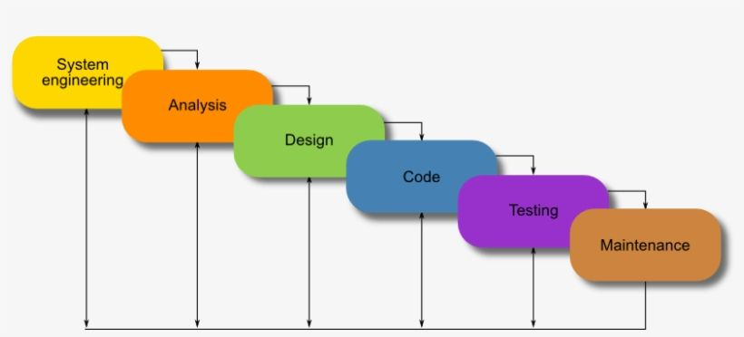
- One phase must be completed before moving to the next phase.

Fig. Waterfall Model

- Advantages
- Easy to understand
- Simple to manage
- Well documented
- Suitable for small projects
- Disadvantages
- Requirement changes are difficult
- Testing starts very late
- High risk of failure if requirements change

- Spiral Model
- The Spiral Model combines development activities with risk analysis.
- Each cycle goes through planning, development, testing, and risk assessment.
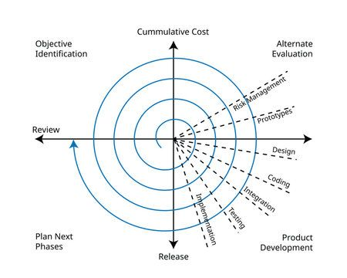

Fig. Spiral Model

- Advantages
- Better risk management
- Suitable for large projects
- Flexible
- Disadvantages
- Expensive
- Complex to manage
- Requires experienced teams

- V Model / V-V Model
- The V Model is an extension of the Waterfall Model.
- Each development phase has a corresponding testing phase.
- Verification Side:
- Requirements
- Design
- Architecture
- Coding
- Validation Side:
- Unit Testing
- Integration Testing
- System Testing
- Acceptance Testing
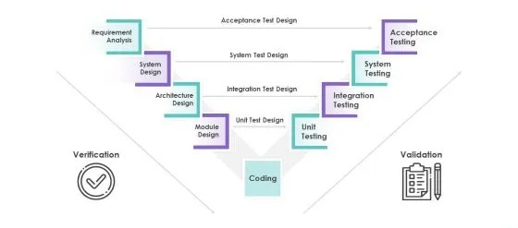

Fig. V-Model

- Advantages
- Early test planning
- Better quality assurance
- Easy defect identification
- Disadvantages
- Difficult to accommodate changes
- Expensive for changing requirements
- Prototype Model
- A working model of the application is created first.
- Customers review the prototype and provide feedback before actual development starts.
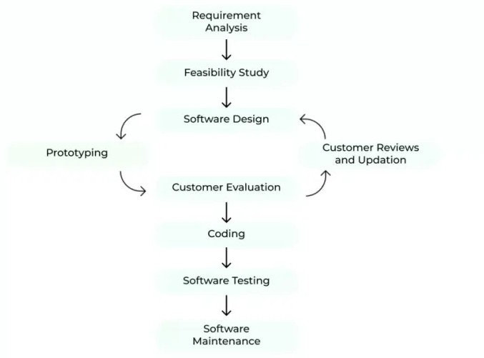

Fig. Prototype Model

- Advantages
- Better requirement understanding
- Early customer feedback
- Reduced misunderstandings
- Disadvantages
- Frequent changes increase cost
- Customers may expect the prototype to be the final product

- Agile Model
- The Agile Model develops software in small iterations called Sprints.
- Each sprint generally lasts between one and four weeks.
- Requirements can change even during development.
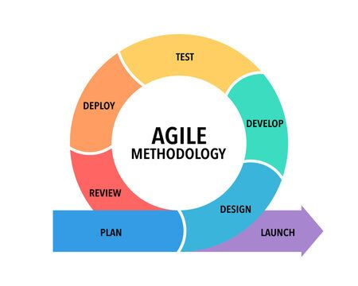

Fig. Prototype Model

- Advantages
- Flexible
- Faster delivery
- Continuous feedback
- Easy to accommodate changes
- Better customer satisfaction
- Disadvantages
- Requires active customer involvement
- Documentation may be limited
- Difficult to estimate cost and time

- Key Learnings
- SDLC is a systematic approach for developing software.
- Every software project follows multiple phases from requirement gathering to maintenance.
- Different SDLC models are used depending on project requirements.
- Testing is one of the most important phases of SDLC because it ensures software quality.
- Agile is the most widely used SDLC model in modern software development.

DAY 3 : Introduction to STLC

- What is STLC ?
- Software Testing Life Cycle (STLC) is a sequence of activities performed during the software testing process to ensure that the software meets the required quality standards.
- In simple words, STLC is a step-by-step process that guides testers from understanding the requirements to completing the testing process.

- Why is STLC important ?
- Improves Software Quality :
STLC ensures that every functionality of the application is tested properly.
- Detects Defects Early :
Finding bugs during testing reduces the cost of fixing them later.
- Provides Structured Testing
Testing activities are organized into different phases, making the process efficient.
- Improves Test Coverage :
Every requirement is tested to ensure nothing is missed.
- Ensures Customer Satisfaction :
A properly tested application provides a better user experience.

- Objectives of STLC
• Verify application functionality.
• Identify defects.
• Ensure all requirements are tested.
• Improve software quality.
• Deliver a bug-free application.
• Increase customer satisfaction.

- Benefits of STLC
- Ensures systematic and organized testing.
- Improves the quality of the software.
- Detects defects at an early stage.
- Reduces development and maintenance costs.
- Ensures complete test coverage.
- Improves communication among team members.
- Increases customer confidence and satisfaction.
- Helps deliver reliable and stable software.

- Entry Criteria
- Entry Criteria are the conditions or requirements that must be completed before starting a particular phase of the Software Testing Life Cycle (STLC).
- These criteria ensure that all necessary inputs, documents, resources, and environments are ready before testing activities begin.
- In simple words, Entry Criteria answer the question:
"What should be ready before we start this phase?"
- If the entry criteria are not satisfied, the testing phase should not begin because it may affect the quality and efficiency of testing.

- Exit Criteria
- Exit Criteria are the conditions or requirements that must be completed before ending a testing phase.
- They ensure that all planned testing activities have been completed successfully before moving to the next phase.
- In simple words, Exit Criteria answer the question:
"What should be completed before we finish this phase?"
- If the exit criteria are not met, the testing phase cannot be considered complete.

- Phases of STLC

Phase 1: Requirement Analysis
- Requirement Analysis is the first phase of STLC.
- In this phase, testers study the Software Requirement Specification (SRS) document to understand the application's functionality and identify what needs to be tested.
- The primary goal is to understand the business requirements and identify all testable requirements.
Activities Performed
- Study the SRS document.
- Understand business requirements.
- Identify functional requirements.
- Identify non-functional requirements.
- Identify testable requirements.
- Understand the project scope.
- Clarify doubts with the Business Analyst or Client.
- Identify automation feasibility (if applicable).
Deliverables
- Requirement Analysis Document
- Requirement Traceability Information
- List of Testable Requirements
- Feasibility Report
Phase 2: Test Planning
- Test Planning is the phase where the complete testing strategy is prepared.
- The Test Lead or Test Manager prepares the Test Plan.
- This phase decides how testing will be performed.

Activities Performed
- Define testing scope.
- Select testing types.
- Prepare Test Strategy.
- Estimate testing effort.
- Allocate resources.
- Estimate project cost.
- Decide testing schedule.
- Identify project risks.
Deliverables
- Test Plan Document
- Test Strategy Document
- Resource Plan
- Test Schedule
- Risk Analysis Report
Phase 3: Test Case Development
- In this phase, testers create test cases based on business requirements.
Activities Performed
- Write Test Cases.
- Review Test Cases.
- Prepare Test Data.
- Update RTM.
- Review Test Scenarios.

Deliverables
- Test Cases
- Test Data
- RTM
- Test Scenarios
Phase 4: Test Environment Setup
- A testing environment is prepared before executing test cases.
- The environment should closely resemble the production environment.
Activities Performed
- Install application.
- Configure server.
- Configure database.
- Install testing tools.
- Create test accounts.
- Verify environment readiness.
Deliverables
- Test Environment
- Environment Readiness Report
Phase 5: Test Execution
- During this phase, testers execute all prepared test cases.
- If defects are found, they are reported to developers.
Activities Performed
- Execute Test Cases.
- Compare Expected and Actual Results.
- Record Test Results.
- Report Bugs.
- Retest Fixed Bugs.
- Perform Regression Testing.
Deliverables
- Test Execution Report
- Defect Report
- Test Status Report
Phase 6: Test Closure
- The testing team evaluates the testing process and prepares final reports.
Activities Performed
- Verify completion of testing.
- Prepare Test Summary Report.
- Analyze defect statistics.
- Prepare Test Closure Report.
- Document lessons learned.
- Obtain client approval.
Deliverables
- Test Summary Report
- Test Closure Report
- Test Metrics
- Final Sign-Off

- Real-Time Example: Testing an E-Commerce Website
I. Requirement Analysis
Study requirements for:
- User Registration
- Login
- Search Products
- Add to Cart
- Wishlist
- Online Payment
- Order Tracking
II. Test Planning
Plan:
- Functional Testing
- Regression Testing
- Smoke Testing
Estimate:
- 4 Test Engineers
- 20 Days
III. Test Case Development
Prepare test cases for:
- Login
- Registration
- Search Products
- Cart
- Checkout
- Payment
IV. Test Environment Setup
Configure:
- QA Server
- Database
- Chrome Browser
- Test User Accounts
V. Test Execution
- Execute all prepared test cases.
- Report defects if any functionality fails.
- Retest fixed defects and perform regression testing.
VI. Test Closure
Prepare:
- Test Summary Report
- Defect Summary
- Lessons Learned
- Final Sign-Off

- SDLC vs STLC

SDLC | STLC
Software Development Life Cycle | Software Testing Life Cycle
Focuses on software development | Focuses on software testing
Performed by Developers, Architects, Business Analysts | Performed by Test Engineers
Starts with Requirement Gathering | Starts with Requirement Analysis
Ends with Maintenance | Ends with Test Closure

- Key Learnings
✔ STLC is a structured process followed by testers.
✔ Every phase has defined activities, entry criteria, exit criteria, and deliverables.
✔ Proper planning improves testing efficiency.
✔ Test cases help verify application functionality.
✔ Test execution identifies defects before software reaches users.

